1. **[Tool] ViVOPay_KeyLoading.exe**
2. 選 KPK Form, 按 Enter Key 後會出現

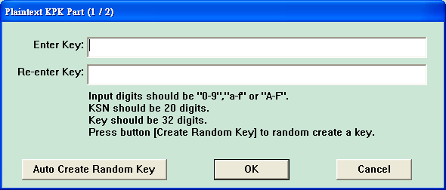

Key1 = “50DC8AE5D41F0137145988FA5B6C621E” (自動隨機產生即可)

Key2 = “47A8BE3A1E0DB58BBF802B5A3C2FA144” (自動隨機產生即可)

Key3 = “5FEAE4C88C2D43B538ED8EDEF4D9D773” (自動隨機產生即可)

1. 選 DUKPT Key Form, 如果要 load admin key, 則 Key Index 選”2”, Key Parts 選 “2”, Algorithm “TDES”,

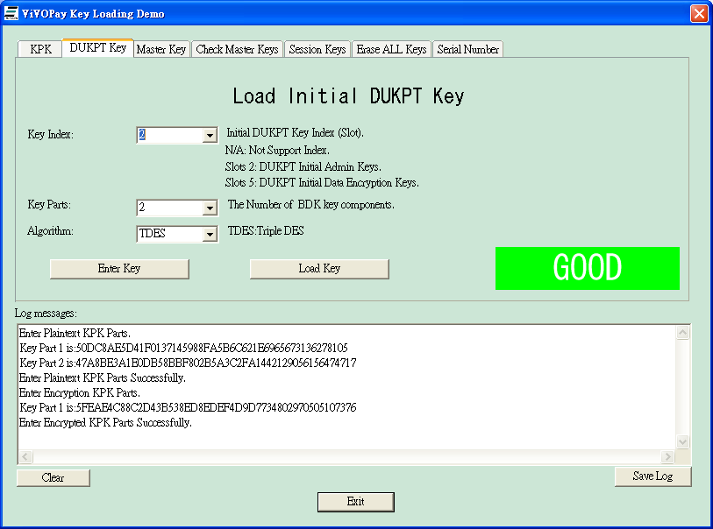

按 Enter Key，

KSN = “629949012c0004600000” (自動隨機產生即可)

Key1 = “00000000000000000000000000000000”

Key2 = **“823cb03a0dc60b27aadc8aaf79ce6eda”** (可隨意填入，資料屆時將用在RKI_demo工具)

1. 選 Erase All Keys Form, 按 “Erase All Key”
2. 選 “KPK Form”, 按 “Load Key”
3. 選 “DUKPT Key”, 按 “Load Key”
4. 選 “DUKPT Key”, “Key Index” 選 5, 按 Enter Key,

KSN = “629949012c0004600000” (自動隨機產生即可)

Key1 = “00000000000000000000000000000000” (自動隨機產生即可)

Key2 = “0123456789abcdeffedcba9876543210” (自動隨機產生即可)

然後按 “Load Key”

1. **[Tool] RKI_demo.exe**

開啟後, Key Type 選”ICC”,

將 Interface改成”RS232”,

將 AdminBDK 填入 **“823cb03a0dc60b27aadc8aaf79ce6eda”,**

按 “Load Key”

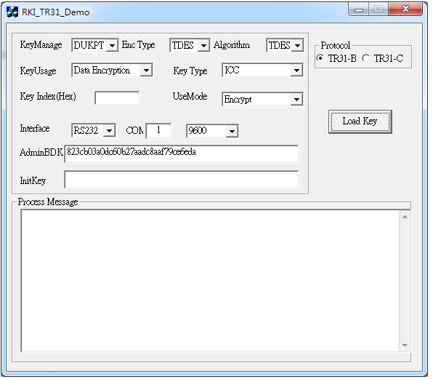

KSN = “629949012c0004600000”

Key = “00000000000000000000000000000001”

